CERTIFICATE
OF
GRADUATION
QINGDAO AGRICULTURAL UNIVERSITY

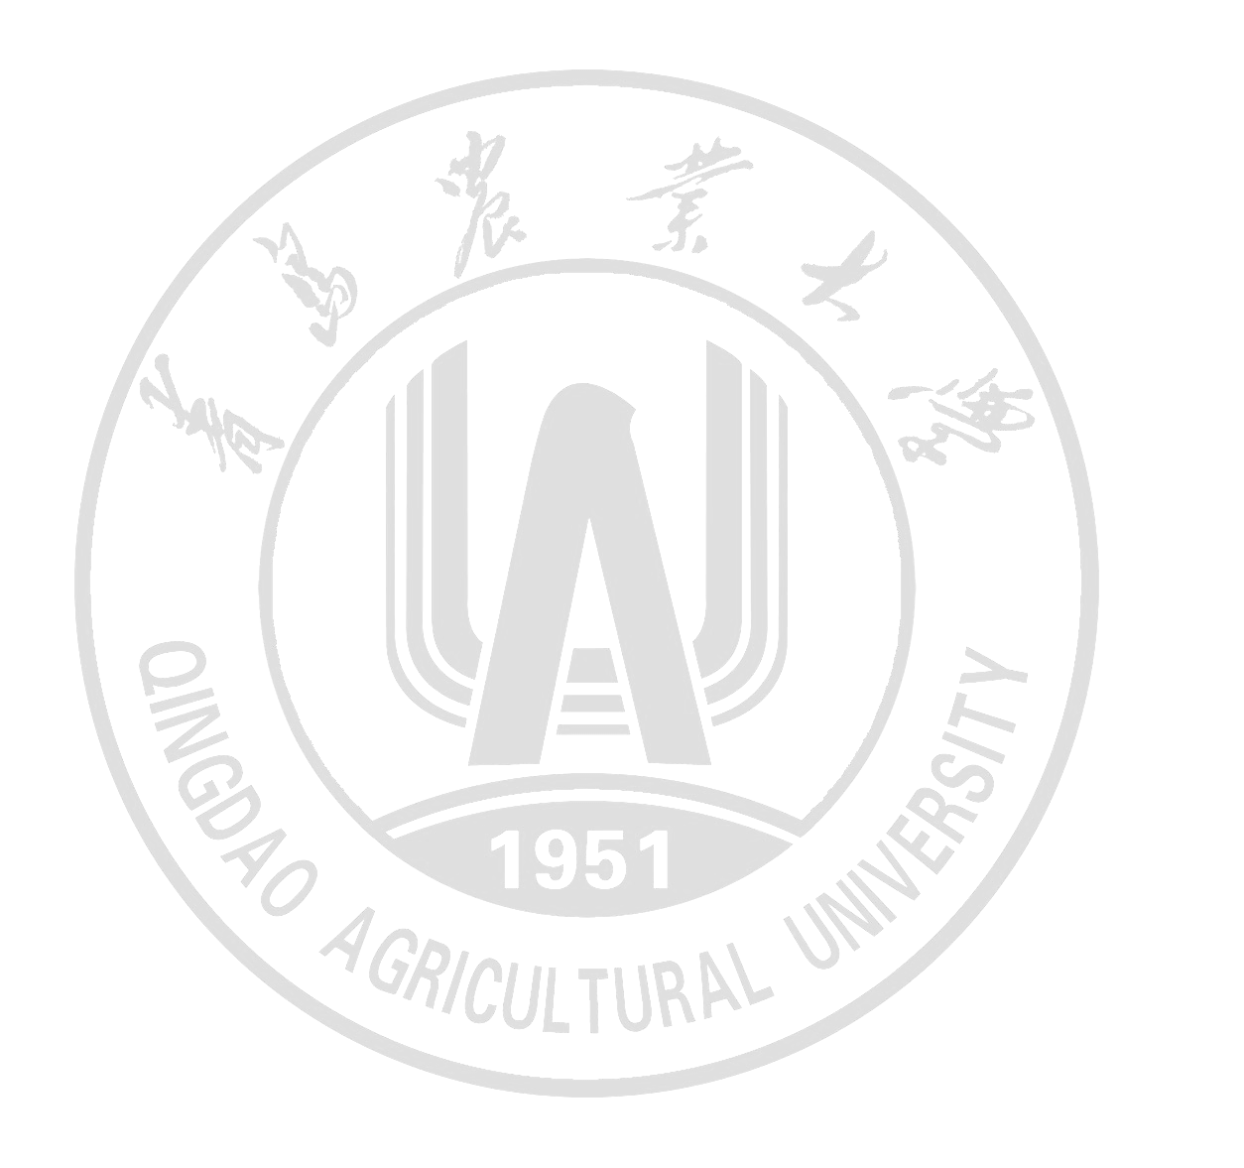
This is to certify that Li Jiaqing, female, born on June 23, 2002, majoring in Logistics Management in the College of Economics and Management of Qingdao Agricultural University from September 2020 to June 2024, has accomplished this four-year bachelor program and is hereby granted graduation.

Professor Zhao Jinshan
President of Qingdao Agricultural University
Date of Issuance: June 20, 2024（毕业证书日期，打印时删掉文字）
No.XXXXXXXXXXX（毕业证书编号，打印时删掉文字）

打印时红色内容改为黑色，删掉本行文字

