BACHELOR DEGREE
Issued by the Ministry of Education of the
People’s Republic of China

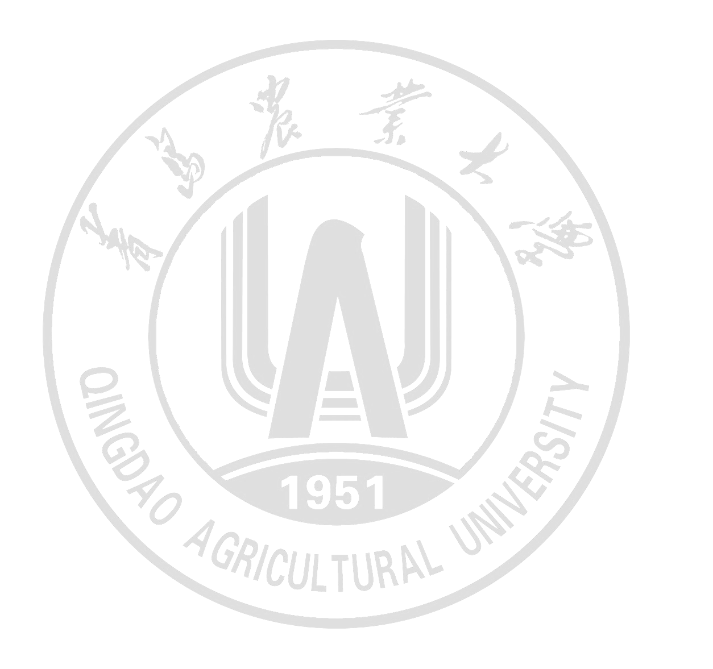
This is to certify that Li Jiaqing, female, born on June 23, 2002, majoring in Logistics Management in the College of Economics and Management of Qingdao Agricultural University from September 2020 to June 2024, has accomplished this four-year bachelor program. In accordance with the Regulations on Academic Degrees of the People’s Republic of China, the aforesaid student is hereby conferred the Bachelor’s degree in Management.

Professor Zhao Jinshan
Chairman of the Degrees Committee
Qingdao Agricultural University
Date of Issuance: June 20, 2024（学位证书日期，打印时删掉文字）
No.XXXXXXXXXXX（学位证书编号，打印时删掉文字）

打印时红色内容改为黑色，删掉本行文字

